ONLINE GIFT SHOP (Koseli)

BY
Aakrity Tuladhar
7-2-551-116-2019
And
Jolly Kansakar
7-2-551-132-2019
National College of Computer Studies

A Software Engineering Project Report Submitted to
Faculty of Management, Tribhuvan University
in partial fulfilment of the requirements for the degree of
Bachelor of Information Management (BIM)

Paknajol, Kathmandu
July, 2023

STUDENT DECLARATION
This is to certify that we have completed the Software Engineering Project entitled “Online Gift Shop (Koseli)” under the guidance of “Ms. Sachita Maharjan” in partial fulfilment of the requirements for the degree of Bachelor of Information Management (BIM) at the Faculty of Management, Tribhuvan University. This is our original work and we have not submitted it earlier elsewhere.

Signature:

Name: Aakrity Tuladhar and Jolly Kansakar
Date: June 2023

CERTIFICATE FROM THE SUPERVISOR
This is to certify that the summer project entitled “Online Gift Shop” is an academic work done by ”Aakrity Tuladhar” and “Jolly Kansakar” in the partial fulfilment of the requirements for the Bachelor of Information Management (BIM) at the Faculty of Management, Tribhuvan University under my guidance and supervision. To the best of our knowledge, the information presented by him/her in the summer project report has not been submitted earlier.

Signature of the Supervisor
Name: Ms. Sachita Maharjan
Designation: Supervisor
Date: June 2023

ACKNOWLEDGEMENT
This Software Engineering Project entitled “Online Gift Shop” under the guidance of “Ms. Sachita Maharjan” is prepared in partial fulfilment of requirements for the degree of Bachelor of Information Management at the Faculty of Management, Tribhuvan University. First of all, we would like to thank the National College of Computer Studies for giving us the opportunity to conduct this software engineering project. We would like to express our sincere gratitude to our supervisor for providing invaluable guidance, comments, and suggestions throughout the course of this software engineering project and especially for motivating us to work harder. We would like to thank all those who have directly and indirectly been connected to this project.

Aakrity Tuladhar
7-2-551-116-2019
And
Jolly Kansakar
7-2-551-132-2019

EXECUTIVE SUMMARY
The faculty of management Tribhuvan University has introduced a Software Engineering report for BIM 6th semester students. The Software Engineering Project is an essential requirement for graduation.
Unlike traditional commerce which requires humans to go physically to the store to purchase items, nowadays e-commerce has made it easier for the consumer to order products online and deliver them to their doorstep.
Today in this world of technology we can order any product with the help of our mobile or a computer. The main advantage of e-commerce over traditional commerce is the user can browse online shops, compare prices, and order merchandise sitting at home on their PC.
Our website provides the customers with various kind of product related to their needs and wants. For particular celebrations we provide particular gifts. The customer can browse through our website and decide to purchase some items, then they can proceed towards payment through the help of online payment or they can also pay with cash on delivery. This process normally takes less than 20 seconds to complete.
E-commerce is in growing phase in our country, so it isn’t at 100% completion but comes with a lot of challenges to face. Security and scams are one of the biggest issues running in the world of e-commerce. Traditional buyers and sellers are still paranoid about conducting business online.

Table of Contents
STUDENT DECLARATION i
CERTIFICATE FROM THE SUPERVISOR ii
ACKNOWLEDGEMENT iii
EXECUTIVE SUMMARY iv
List of Figure vii
List of Tables viii
ABBREVIATIONS ix
CHAPTER 1: INTRODUCTION 1
1.1 Project Introduction 1
1.2 Objective of Project 1
1.3 Limitation of Project 1
1.4 Software Development Methodology 1
1.4.1 Project Framework 2
1.4.2 Data and Information 2
1.4.3 Tools Used 3
CHAPTER II: TASK AND ACTIVITIES PERFORMED 4
2.1 Requirement Specification 4
2.1.1 Functional Requirement 4
2.1.2 Non-Functional Requirement 6
2.2 Feasibility Study 6
2.2.1 Technical Feasibility: 6
2.2.2 Operational Feasibility: 6
2.2.3 Economic Feasibility: 6
2.2.4 Legal Feasibility: 6
2.2.5 Schedule Feasibility: 6
2.3 System Analysis 7
2.3.1 System Modelling 8
2.3.2 Process Modelling 9
2.4 System Design 14
2.4.1 State Diagram 14
2.5 System Implementation 15
2.6 System Testing 16
2. 7 Findings 20
CHAPTER III: DISCUSSION AND CONCLUSION 21
3.1 Discussion 21
3.2 Conclusion 21

List of Figure
Figure 2. 1 Use case Diagram 5
Figure 2. 2 ER Diagram 8
Figure 2. 3 Activity Diagram 10
Figure 2. 4 DFD Diagram 12
Figure 2. 5 Sequence Diagram 13
Figure 2. 6 State Diagram 14

List of Tables
Table 2. 1 Use case Table 5
Table 2. 2 ER Description 8
Table 2. 3 Activity Description 10
Table 2. 4 DFD Description 12
Table 2. 5 Sequence Diagram Description 13
Table 2. 6 State Diagram Description 14
Table 2. 7 Login Testing 18
Table 2. 8 Register Testing 19
Table 2. 9 Add to Order Testing 20

ABBREVIATIONS

BIM Bachelor of Information Management
CSS Cascading Style Sheet
FOM Faculty of Management
NFR Non-Functional Requirements
SEP Software Engineering Project
TU Tribhuvan University
UI User Interface
UML Unified Modeling Language

CHAPTER 1: INTRODUCTION

1.1 Project Introduction
Koseli is an ecommerce-based website designed to provide the best quality of gifts for the customers. Customers can look for the gifts that they would like to purchase for the specific occasion and purchase it for their loved ones. We provide various categories of gifts for occasions such as birthday, anniversary, mother’s day, special gifts, father’s day, valentine’s day and we also provide decorations services for birthdays such as balloons, candles, wallpapers, lights and other various decorative items.
We have created a brand with a good reputation that has put our customer’s faith in us to provide them with high quality products for the price they paid. It is our pleasure to do business and see our customers smile and be happy with what they have ordered. We are aiming to be one of the leading ecommerce websites as we grow in future.
We love and enjoy our job of delivering gifts in Nepal to your loved ones. We attempt to make every gift delivery a perfect happy delivery. We deliver all over Nepal and every product that we deliver is handled with proper care and safely delivered to your doorstep.

1.2 Objective of Project
The main objective of Koseli is to provide gifts for various occasions to our customers.
The objectives of our project are
- To create a website having separate views for both the admin and the users of the website.
- To provide a user-friendly website with limited control of the website like logging into the website to view or purchase gifts.
- To provide gifts with various categories to choose from
- To create a secure database with the help of password authentication.
- To create a centralized system-based website with multiple logins features as well.

1.3 Limitation of Project
We have tried to lessen our limitations but not everything is perfect in this world and we have our own limitations as well, which are mentioned below:
- Time limitation
- Location cannot be added to the user
- Limited products for specific occasions only
- No order cancelation process

1.4 Software Development Methodology
Our project uses Rational Unified Process (RUP). RUP is a software development process for object-oriented models. It's also known as the unified process model. The main goal of RUP is to create high-quality software with a predictable budget and time frame. Each of the life cycle phases can be repeated, if needed until the main objectives are met.

Process:

Inception
Elaboration
Construction
Transition
Go / No Go

Inception:
- Communication and planning are mainly done
- It identifies the scope of the project using a use-case model allowing managers to estimate the costs and time required.
- The project plan, project goal, risks, use-case model, and project description are made.
Elaboration:
- Planning and modelling are mainly done
- Detailed evaluation, the development plan is carried out and diminishes the risk.
- Revise or redefine use-case model (approx. 80%), and business case risks.
Construction:
- The project is developed and completed.
- A system or source code is created and then testing is done.
- Coding takes place.
Transition:
- The final project is released to the public.
- Update project documentation.
- Defects are removed from the project based on feedback from the public.

1.4.1 Project Framework
The overall project is divided into three segments. They are:
a. Introduction
b. Analysis
c. Discussion and Conclusion
- Introduction
In this segment, we have tried to develop a system which is an online gift shop. Not only the objective of the report, issues related to the report, data and tools and techniques used to create are also presented in this segment.
- Analysis
In this segment analysis the software is done using various tools such as UML diagrams.
- Discussion and Conclusion
This section consists of a conclusion from the entire analysis, in order to meet the specified objectives.

1.4.2 Data and Information
The data and information for this report were collected very carefully using two methods: They are:
a. Primary Data Collection Method
b. Secondary Data Collection Method

- Primary Data Collection Method
The primary data are those data that are collected fresh and for the first time. These data are obtained by a study specifically designed to fulfil the data need of the problem at hand. Such data are original in character.

- Secondary Data Collection Method
The secondary data are those which have already been collected by someone else and which have already been passed through the statistical processes. Thus, such data is not originally collected but rather obtained from published or unpublished sources. The secondary data were collected using the internet and books.

1.4.3 Tools Used

- Front end: CSS, JQuery
- Backend: Php
- IDE: VS code
- Laravel composer, Cmd prompt
- Server implementation: XAMPP, PhpMyAdmin

CHAPTER II: TASK AND ACTIVITIES PERFORMED

2.1 Requirement Specification
Software Requirements Specification (SRS) Format as the name suggests, is a complete specification and description of requirements of the software that needs to be fulfilled for the successful development of a software system. The interaction between customers and contractors is done because it’s necessary to fully understand the needs of customers. The requirements can be classified into two categories. They are:

2.1.1 Functional Requirement
Functional Requirements are the state of services the system should provide, how the system should react to the particular input and how the system should behave in a particular situation. A typical functional requirement will contain a unique name and number, a brief summary, and a rational. This information is used to help the reader understanding why the requirement is needed, and to track the requirement through the development of the system. Some of the functional requirements of "Online Gift Shop" includes:
From the system, the functional requirements are:

Functional Requirement number | Functional Requirement Description
FR1 | User should be able to see the items with the price
FR2 | The user should be able to log in and it should store items in add to cart
FR3 | There should be an admin page and a customer view page
FR4 | There should be a connection with the database
FR5 | There should be an online payment system
FR6 | There should be a category of a gift like Father’s Day, Mother’s Day, etc.
FR7 | The user should be able to search the items
FR8 | Users can be able to order the items according to the category.

2.1.1.1 Use Case Diagram
Use case are the scenario-based technique for requirements. This is used to identify the type of interaction between the system and its users and the actors involved. The functional requirements can be represented by a use case diagram. The use case diagram for this system is
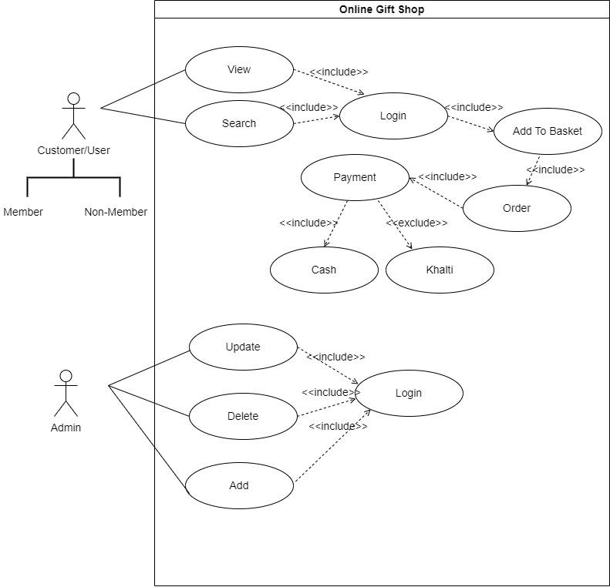

Figure 2. 1 Use case Diagram

Use Case Diagram
Actor | Admin, customers
Description | The admin and customers are able to login to the system, the admins have special privileges such as adding, updating and deleting the item etc. They need to register and login to the system in order to continue the website. The registration module information will ask for the name, email and password to login.
Data | Data includes the information of the bakery item that the customer can order. It also includes the login information of the customers and the admins.
Stimulus | The command can be issued by all the actors for e.g. the admin can add the item or add the item availability.
Response | For the stimulus instance provided above, the system may respond as an update in the data table, adding the item and letting the admin view the customer orders.
Comments | Admin needs their respective passwords to have access to the information.
Table 2. 1 Use case Table

2.1.2 Non-Functional Requirement

- The website should be user-friendly.
- The website should be fully responsive on all devices.
- The data should be secure.
- This website should be effective.
- This website should be helpful for the admin side.

2.2 Feasibility Study
Feasibility study is a study to evaluate the feasibility of a proposed project or system. It is the feasibility analysis or a measure of the software product in terms of how beneficial product development is from a practical point of view. The purpose of the study is to determine if the system's request should proceed further.

2.2.1 Technical Feasibility:
In the online gift shop, we used laravel for the programming. We did an online gift shop according to the category or event for the required gift. All the information about whether the technologies and resources needed to build the project are referenced from the internet.

2.2.2 Operational Feasibility:
This project is easy for the client to find their gifts according to their requirement which has different categories like Father’s Day, Mother’s Day, etc. This is user-friendly as the gift requirement is shown on the screen and the user can get the item according to their needs.

2.2.3 Economic Feasibility:
Since the equipment applications for the software development of the software are readily available, no extra expenses will cost. The software should be as beneficial for the client and admin as they spend on using the system.

2.2.4 Legal Feasibility:
It is a study of the project and is analyzed from a legal point of view. This includes analyzing barriers to the legal implementation of projects, data protection acts or social media laws, copyright, etc.

2.2.5 Schedule Feasibility:
In Schedule Feasibility Study mainly timelines/deadlines are analyzed for proposed projects which includes how many times teams will take to complete the final project .The purpose of the project may fail if it can’t be completed on time. In many cases a project will be unsuccessful if it takes longer than it was estimated: some external environment conditions may change, hence a project can lose its benefits, expediency and profitability.

Timeline for our project:

Start date | Days to complete | Description
5-April | 20-Apr | Planning/research
21-April | 30-Apr | Design
6-May | 20-May | Develop
21-May | 27-May | Testing
28-May | 30-Jun | Presentation for project
6-Jun | 13-Jun | Follow up
14-Jun |  | Final project presentation with a demo

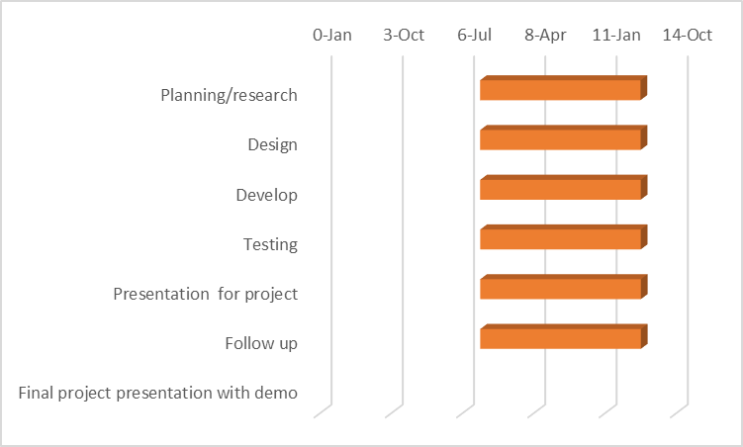

2.3 System Analysis
System analysis is the process by which an individual’s studies a system such that an information system can be analyzed, modeled, and a logical alternative can be chosen. System analysis projects are initiated for the three reasons: problems, opportunities, and directives.

2.3.1 System Modelling
System Modeling involves creating abstract representations of software systems to help software engineers. It is a critical aspect of software development because it enables software engineers to communicate and collaborate effectively, identify potential issues early on in the development process and make informed decisions about the system’s design and implementation.

2.3.1.2 E-R Diagram
ER diagram is a high-level data model used to define the data elements and relationships for a specified system. It develops a conceptual design for the database. It also develops a very simple and easy-to-design view of data. ER diagrams contain different symbols that use rectangles to represent entities, ovals to define attributes, and diamond shapes to represent relationships. (ER-Diagram, 4May, 2021)

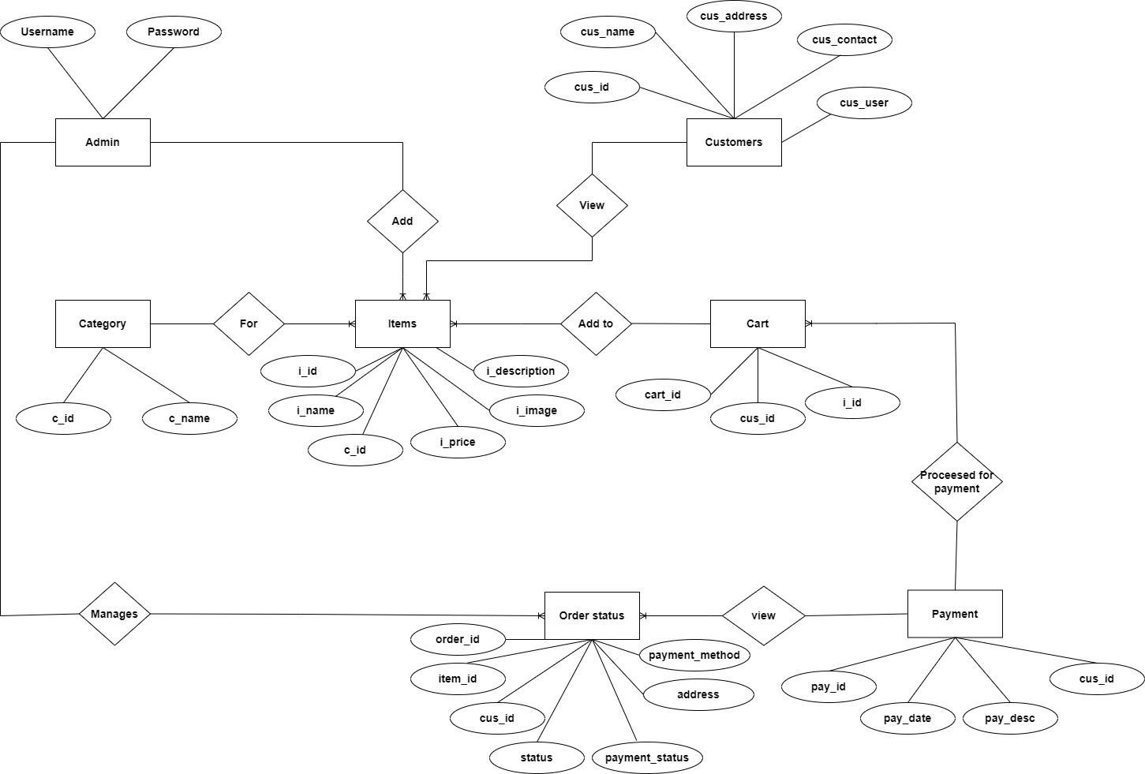

Figure 2. 2 ER Diagram
ER Description
The entities are admin, customer, category, items, cart, order status and payment. Admin can add the item and category. The customer can view the multiple items and add them into the cart. The cart has many to one relationship with payment .After payment the customer can view order status which is managed by the admin.

Table 2. 2 ER Description

2.3.2 Process Modelling
The process modelling is the activity of creating a graphical representation or model of a process to better understand and improve it. It involves identifying the steps, inputs, outputs, and participants involved in a process and representing those visually using diagrams or flowcharts.

2.3.2.1 Activity Diagram
Activity diagrams are a type of behavioral modelling in UML diagrams to describe dynamic aspects of the system. An activity diagram focuses on the condition of flow and sequence in which it happens. It is a diagram that shows the control flow from a start point to a finish point showing the various decision paths that exist while the activity is being executed. (Activity-Diagram, 02 May, 2022)

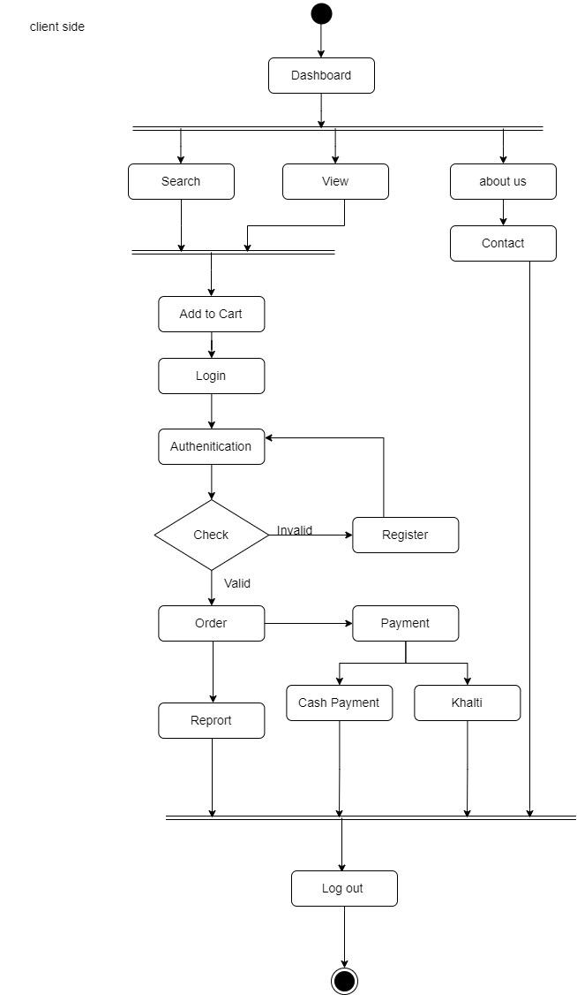

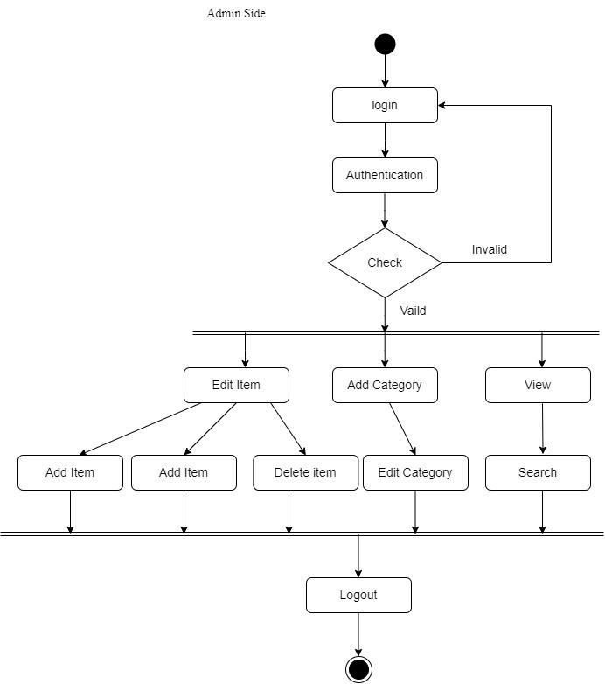

Figure 2. 3 Activity Diagram

Activity Description
The system starts from browsing the website. Where users can view the product and add the item into the cart. In order to add the item into the cart, the user needs to login or register for a new user. The customers should conform the order through checkout. Then the customer goes to the payment section where the customer needs to fill the form and choose the mode of payment.
For the admin side, admin login in order to add, update, delete and view the status and number of admin items. At last the customer and admin can log out form the system.

Table 2. 3 Activity Description

2.3.2.2 Data Flow Diagram
A data flow diagram is a graphical representation of a system or process that shows the flow of data through it. The objective of DFD is to show the scope and boundaries of a system as a whole. It may be used as a communication tool between a system analyst and any person who plays a part in the order that acts as a starting point for redesigning a system. (Data-Flow-Diagram, 30June, 2020)
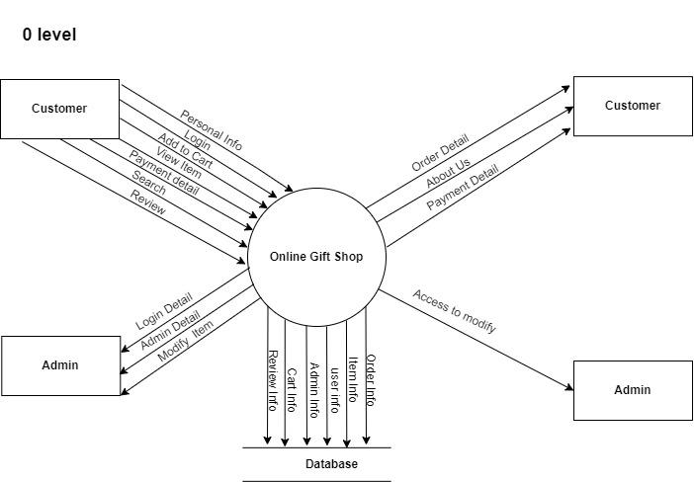
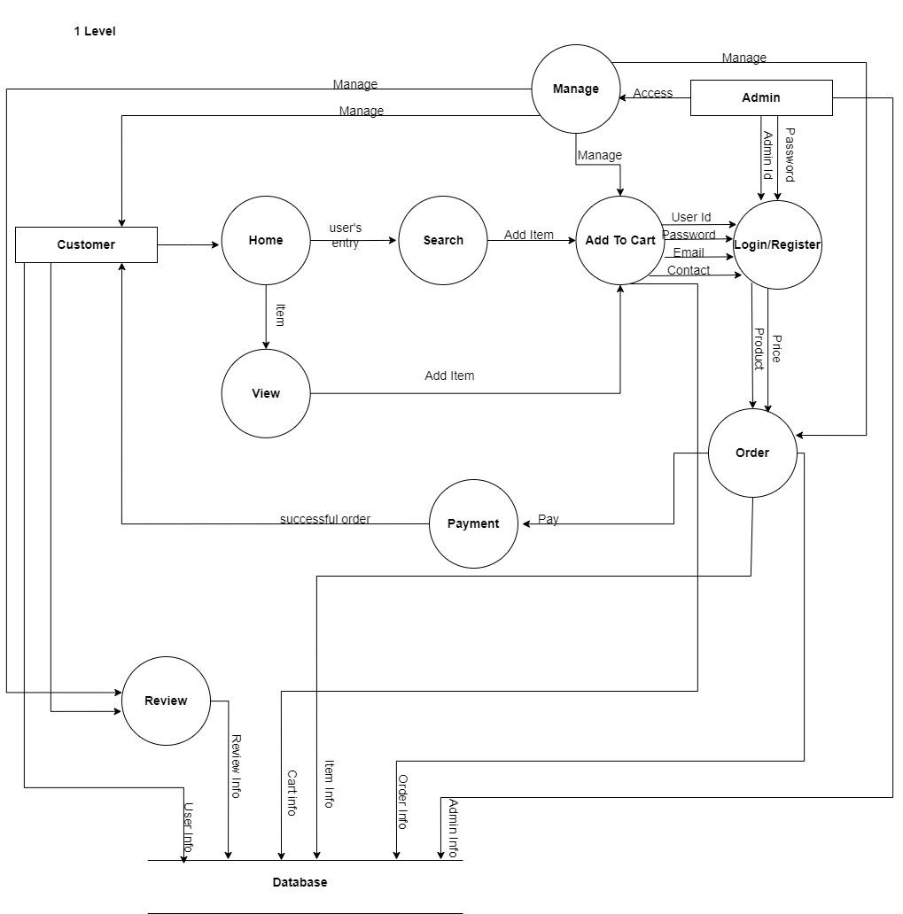

Figure 2. 4 DFD Diagram

DFD Description
The actual system process begins when the user goes to the home page and views the item, the user needs to login or register into the system in order to add the item to the cart. After certain validations, the system redirects to the order list where the user will be viewing their orders. In the order section, the system will identify whether the items are available or not. After the order process, the user needs to checkout from the payment section where the user needs to fill in the details of address and mode of payment. Lastly, the user can go to the home section and logout from the system.
Similarly, on the admin side, the user needs to login in order to add, view, update and view the status of the order.

Table 2. 4 DFD Description

2.3.2.3 Sequence Diagram
A sequence diagram is a type of UML diagram that illustrates the interactions and behaviour between objects or components in a system. They illustrate how the different parts of a system interact with each other to carry out a function, and the order in which the interactions occur when a particular use case is executed. A sequence diagram is structured in such a way that it represents a timeline that begins at the top and descends gradually to mark the sequence of interactions. Each object has a column and the messages exchanged between them are represented by arrows. (Sequence-Diagram, 14June,2020)

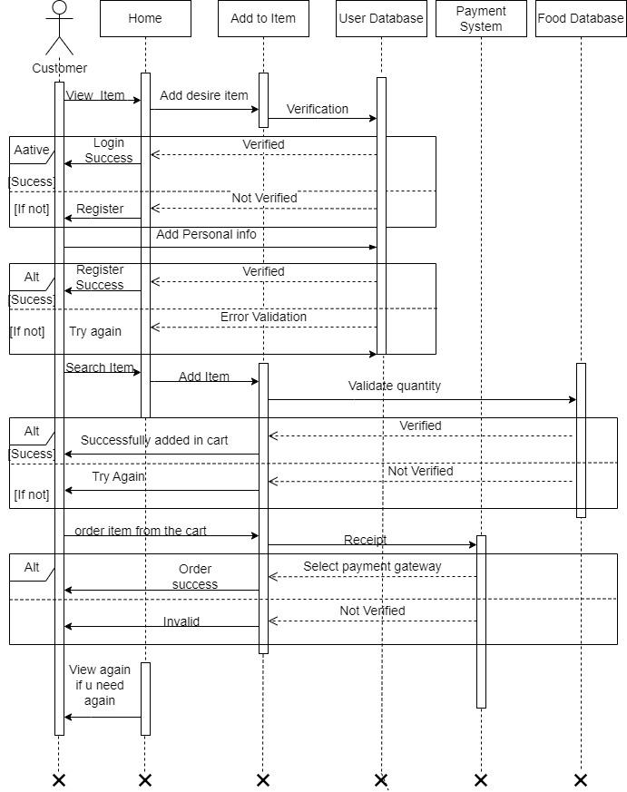

Figure 2. 5 Sequence Diagram

Sequence Diagram Description
The user can view the adding while adding the item into cart, the user needs to login by entering the username and password. Then, the system validates itself. If the required credentials are not entered, it will generate an error and show that the account is invalid. The information about the item is shown. The customer needs to confirm the order if he chooses yes it processes to display payment where the user needs to fill mode of payment. If the customer want to view the item they can go to the home section.

Table 2. 5 Sequence Diagram Description

2.4 System Design
System design refers to the process of defining the architecture, modules, interfaces and data for a system to satisfy specified requirements. It is a multi-disciplinary field that involves trade-off analysis, balancing conflicting requirements, and making decisions about design choices that will impact the overall system. (System-Design, 29 Mar, 2023)

2.4.1 State Diagram
A state diagram is used to represent the condition of the system or part of the system at finite instances of time. It’s a behavioral diagram and it represents the behavior using finite state transitions. State diagrams are also referred to as State machines and State-chart Diagrams. These terms are often used interchangeably. So simply, a state diagram is used to model the dynamic behavior of a class in response to time and changing external stimuli. We can say that each and every class has a state but we don’t model every class using State diagrams. We prefer to model the states with three or more states. (State-Diagram, 07 Nov, 2019)

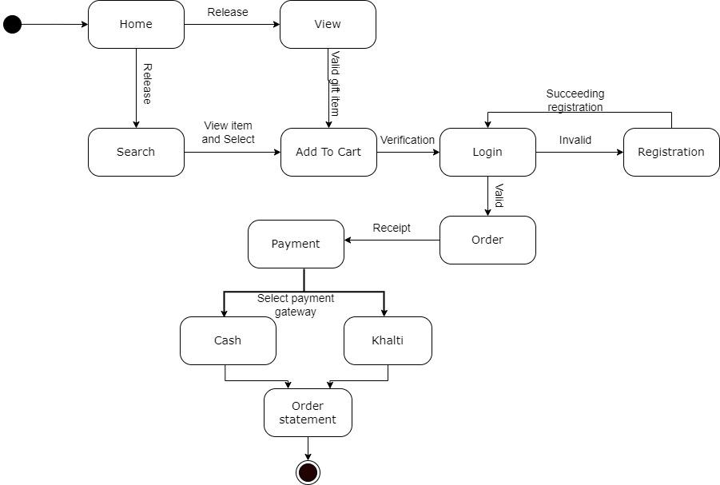

Figure 2. 6 State Diagram

State Diagram Description
The flow of the system begins from the login window. The user can view or search the item and select the item. After selecting the item the user can add their product into the cart. The user needs to be logged in in order to add the items into their cart. If the user doesn't have any account then he/she should register for the further process. The item will be placed as ordered and goes through the payment section where users need to fill the form and select payment mode i.e. cash and khalti . After that the user can view the order statement.

Table 2. 6 State Diagram Description

2.5 System Implementation
In this part, it is actually constructing a new system from scratch with the help of the system design. This part will look at the implementation of the system including the database and the main application. It includes coding, testing and integrating the system to meet its requirements. System implementation is the most important step in case of finalizing the approved web system. We need to justify some basic requirements (software & hardware) so that the system will work or be implemented without having obligations and customer dissatisfaction.
System requirements:
- Operating system: Windows or Mac
- Web Development System: Visual Studio
- Database Management System: MySQL, SQL Server
- Web Browser: Google Chrome, Mozilla Firefox, Safari
Web Module:
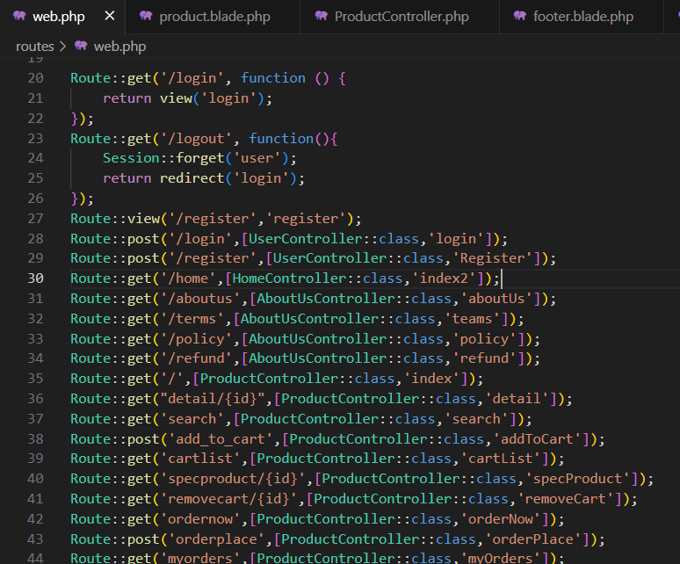

Cart Module:
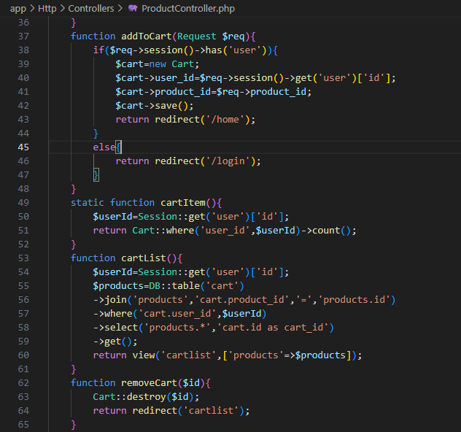

2.6 System Testing
System testing is a type of software testing that evaluates the overall functionality and performance of a complete and fully integrated software solution. It tests if the system meets the specified requirements and if it is suitable for delivery to the end-users. This type of testing is performed after the integration testing and before the acceptance testing. Some of the test cases generated for the few of the modules are given below:
For the test case of this system, the testing method has been used:

Test Case Name: Log in and Logout
Test Case Type: Functional test case
Requirement Number: 1
Module: Login
Severity: critical
Status: --
Release: --
Version: --
Pre-Condition: required one login
Test Data: email- jolly@gmail.com, password: jolly123
Summary: to check the functionality of login

Step no. | Description | Inputs | Expected Result | Actual Result | Status
1 | Run the program | - | Login page must be appear in the screen | As Expected | Pass
2 | Enter invalid email and password | Email: user#gmail.com  Password: user | There should show an error in the screen as email is invalid | As Expected | Pass
3 | Enter valid validation but invalid email and invalid password | Email: user@gmail.com  Password: user | There should show an error in the screen as invalid email and password | As Expected | Pass
4 | Enter valid email and password | Email: jolly@gmail.com, Password: jolly123 | After the valid email and password system should log in and show the home screen | As Expected | Pass
5 | Click on logout | Click logout | When the logout is done the system should logout and show the login page again | As Expected | Pass

Table 2. 7 Login Testing
Test Case Name: Register
Test Case Type: Functional test case
Requirement Number: 2
Module: Register
Severity: critical
Status: --
Release:--
Version:--
Pre-Condition: required one register data
Test Data: name-user1, email- user@gmail.com, password: user123
Summary: to check the functionality of registration

Step no. | Description | Inputs | Expected Result | Actual Result | Status
1 | Run the program | - | Login page must appear on the screen | As Expected | Pass
2 | If the user try to register | Click the register button | Appear the register screen | As Expected | Pass
3 | Enter empty form and submit | Empty form | Shows the error as empty name, email and so on | As Expected | Pass
4 | Fill the form with valid data | name-user1, address-balaju, number-9876500432, email- user@gmail.com, password: user123 | Insert in the database and show the login screen | As Expected | Pass
5 | Try to log in the app | email- user@gmail.com, password: user123 | After valid email and password it login the app and shows the home screen | As Expected | Pass

Table 2. 8 Register Testing

Test Case Name: Add to Cart
Test Case Type: Functional test case
Requirement Number: 4
Module: Add to Cart
Severity: critical
Status: --
Release:--
Version:--
Pre-Condition: required one item to add to order
Test Data: click button to add
Summary: to check the functionality of add to order

Step no. | Description | Inputs | Expected Result | Actual Result | Status
1 | Run the program | - | Home page must appear on the screen at first | As Expected | Pass
2 | View different item | - | Category of the item is displayed | As Expected | Pass
3 | Item search in the nav bar | Enter the name of the item:  “flower” | Display the item according to the enter name | As Expected | Pass
4 | Select an item to add to cart | Add item | After the item are added to the order it should store in the database if it is log in otherwise it shows the login page | As Expected | Pass
5 | Enter valid email and password to log in | Email: jolly@gmail.co,  Password: jolly123 | After the valid email and password system should log in and the item is added to the cart | As Expected | Pass
6 | Select another item to add to cart | Select item to add in order | After login item is added to the order by the user | As Expected | Pass

Table 2. 9 Add to Order Testing

2. 7 Findings
Through the completion of this project, various different information could be found out. There are a lot of differences between classroom and real-life scenarios. We have analyzed problems in detail and possible solutions were also analyzed and few ideas were even implemented. As a solution to the problems, this software is designed and developed. We also found out many other ways to use the programming language used while developing the system. This project has allowed for a project-based learning approach to learn about new methods to solve the problem.

CHAPTER III: DISCUSSION AND CONCLUSION

3.1 Discussion
The main aim of this project was to design a web application for the Online Gift Shop System. Being through the different difficulties and overcoming those difficulties with the help from different sources this project has been successfully completed.
Despite the challenges and problems, the project was completed within a specified duration. The system was tested by people who are indirectly involved in this project.

3.2 Conclusion
During this summer project we have learned a lot of things about web application development. We have tried our best to make this project the best. We have gone through many websites, books and also consulted with the teacher. We have tried to implement my views, ideas, and logic into this project. We have been able to update ourselves about the current demand and trends of the IT market and have gradually built professional knowledge and networks with the various IT personalities which would be very beneficial for our professional career. We were exposed to a professional working scenario where time management was the most important.
This project helped us to get a practical exposure to the working environment. It taught us the importance of communication skills and technological matters. It was a great learning experience for us.

We realized this project has huge benefits for every student. Some of the advantages are:
- It increases problem solving skills.
- It increases exploration and idea generation skills.
- It helps to understand how tasks are performed in a real working environment.
- It helps to worked as team member and time sensibility in job.

References

Activity-Diagram. (02 May, 2022). Ankit Jain. https://www.geeksforgeeks.org/unified-modeling-language-uml-activity-diagrams/
Data-Flow-Diagram. (30June,2020). JavaTpoint. https://www.javatpoint.com/software-engineering-data-flow-diagrams
ER-Diagram. (4May, 2021). JavaTpoint.
https://www.javatpoint.com/dbms-er-model-concept
Sequence-diagram. (14June,2020). Amanda Athuraliya. https://creately.com/guides/sequence-diagram-tutorial/
State-Diagram. (07 Nov, 2019). Ankit Jain. https://www.geeksforgeeks.org/unified-modeling-language-uml-state-diagrams/
System-Design. (29 Mar, 2023). Ankit Jain.
https://www.geeksforgeeks.org/system-design-tutorial/

Screen shots
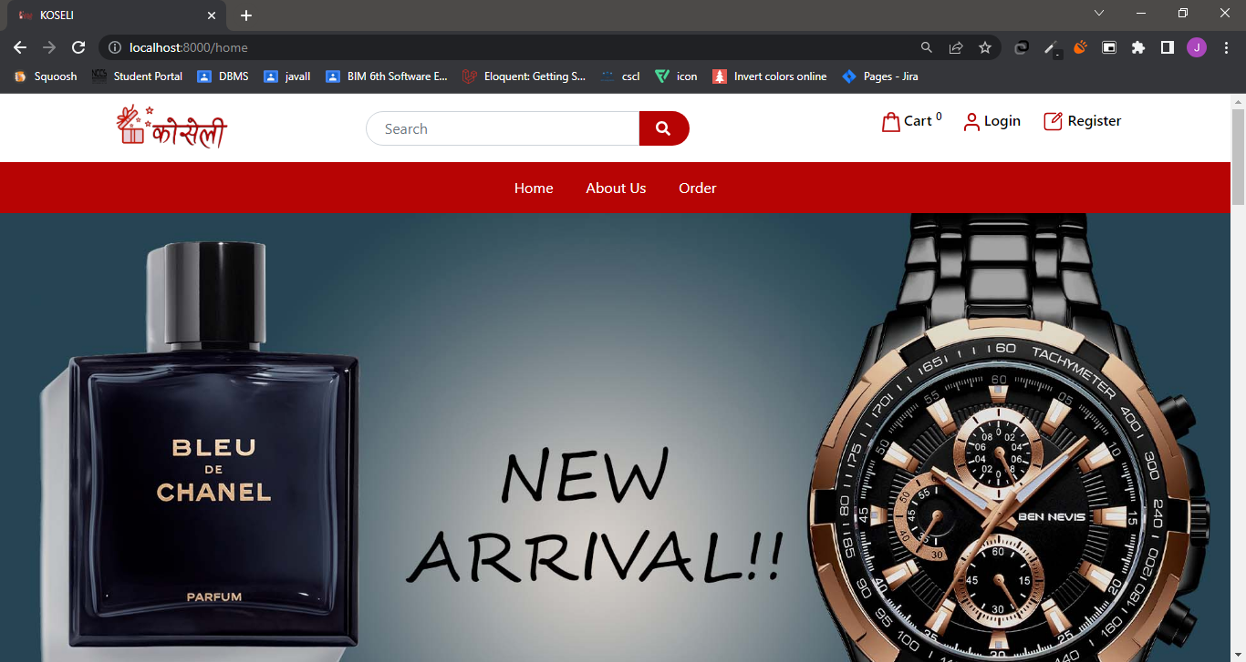

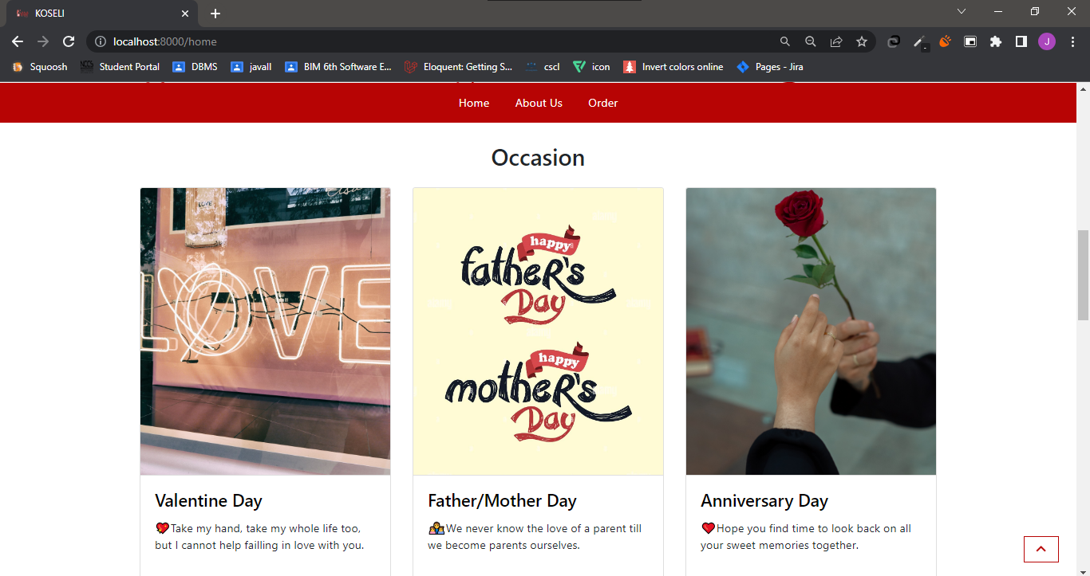
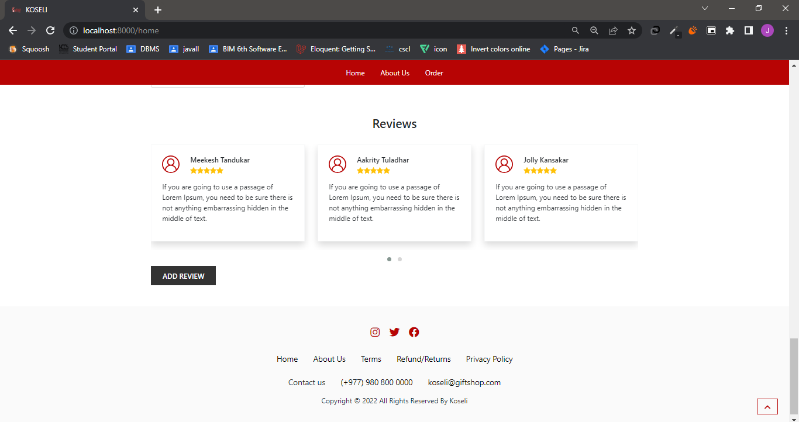

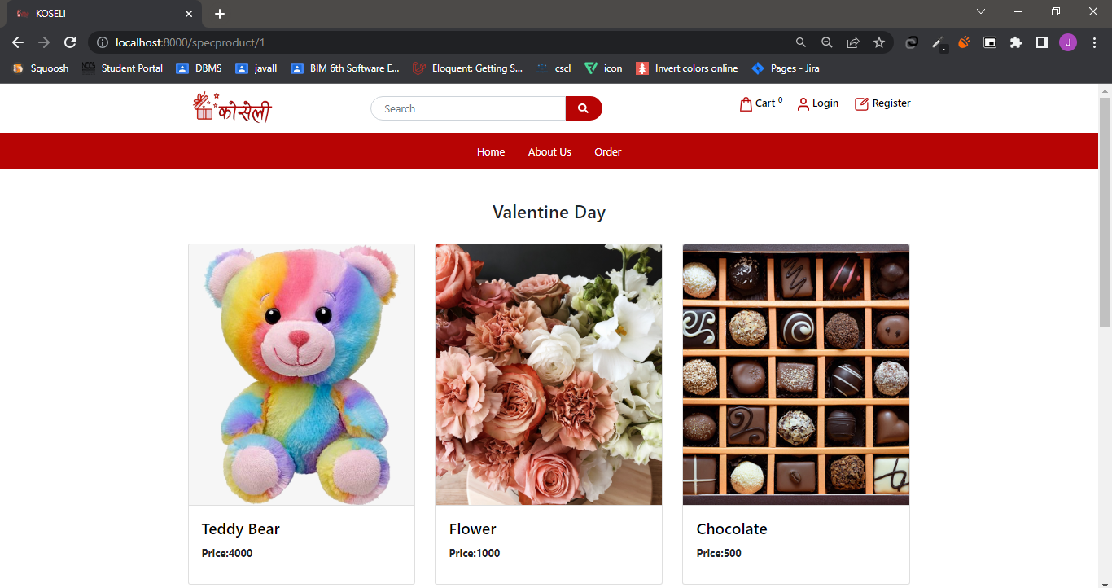

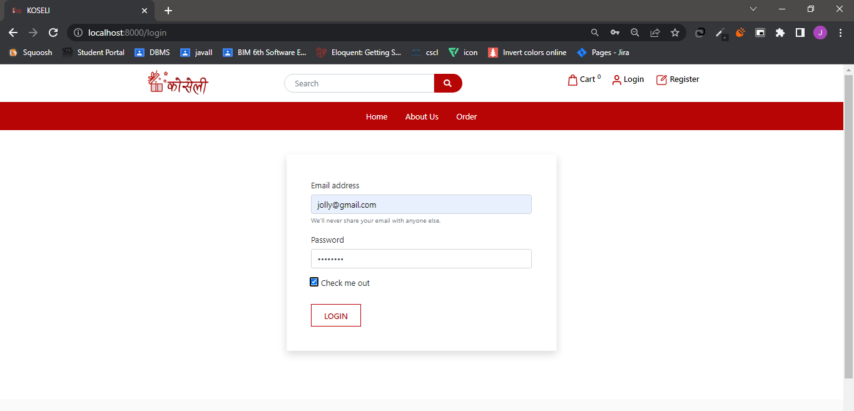
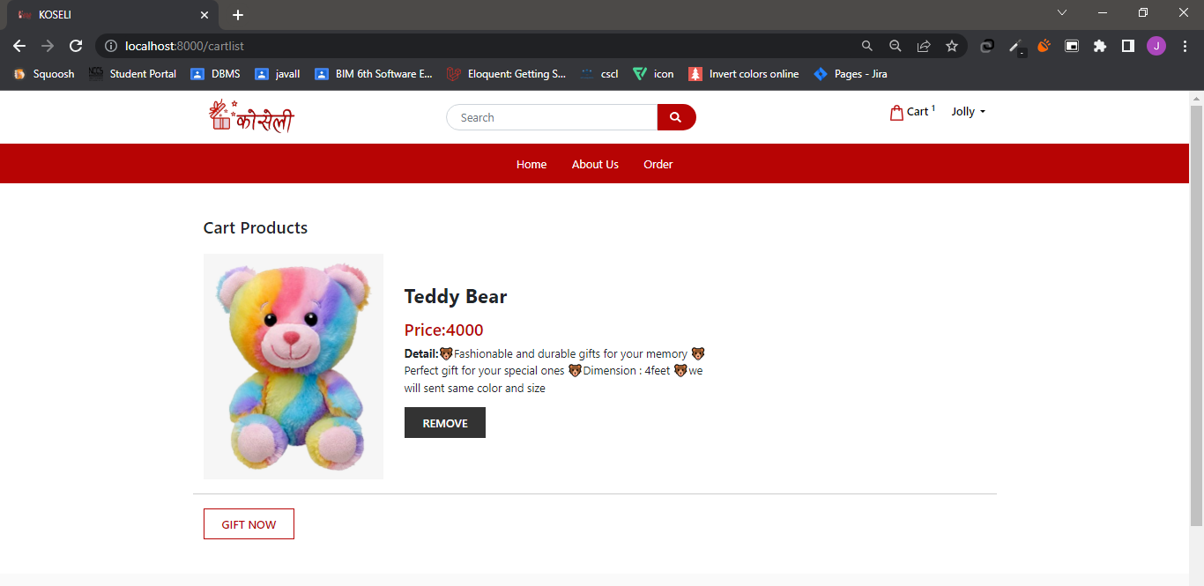
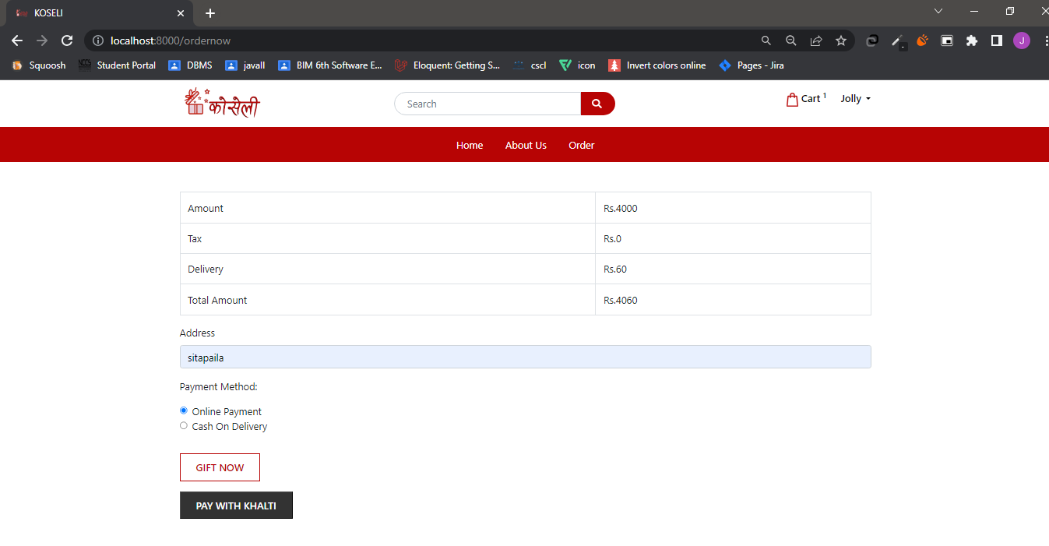
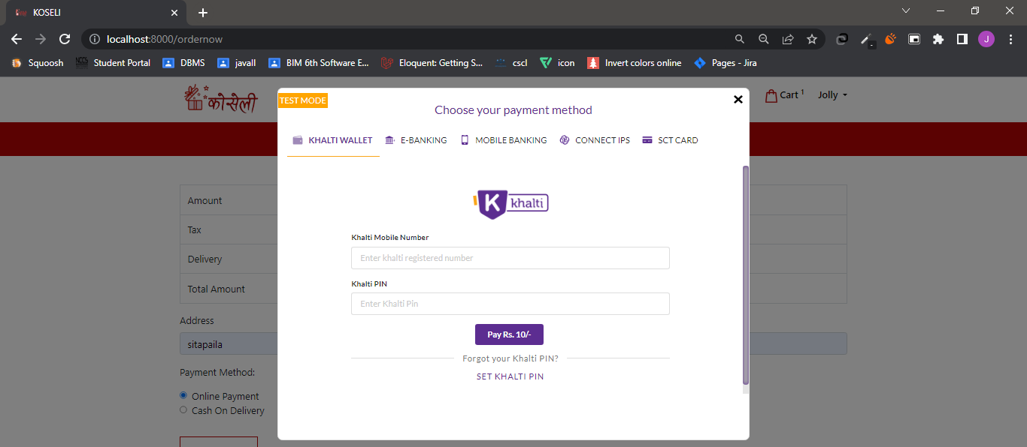
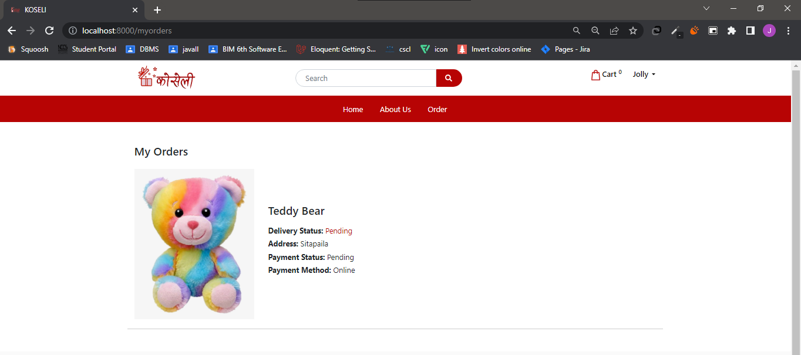

Admin Side
